ICT292 Information Systems Management

# Lab 02: Users, Groups, Permissions in SharePoint

As SharePoint is primarily designed to facilitate user collaboration, it has to also have the capacity to manage users, groups and permissions. Before we get too much further with our exploration of SharePoint, we need to spend some time making sure that we understand how this works, so we will be able to implement it when it comes time to make use of some of the more sophisticated tools in SharePoint.

## Aims:

The primary aims of this lab are for you to:

* Understand the hierarchical inheritance permissions model used by SharePoint

## To be prepared for this lab, you will need to:

* Be correctly enrolled in the unit, and
* Have a web-browser ☺
* Have access to: [ICT292 2024 TMA - Home (sharepoint.com)](https://murdochuniversity.sharepoint.com/sites/ICT2922024TMA)
* Read the page: Understanding permission levels in SharePoint which can be accessed at: <https://docs.microsoft.com/en-us/sharepoint/understanding-permission-levels>

## Introduction

In this lab, you will create a sub-site, just as you did in the previous lab, but will add other users to that site to find out how permissions on sites work. The “Understanding permissions in SharePoint” page makes a number of important points regarding permissions in SharePoint:

1. The root of all permissions in SharePoint is the site collection
2. Permissions automatically flow downhill from the site collection
3. You can create unique permissions for a site, list or library by breaking inheritance.
4. Users below in SharePoint groups.
5. SharePoint groups have permission levels assigned to them.
6. The group a user is in defines what the user can see and do in SharePoint.

### Permission Inheritance

To more fully understand how permissions in SharePoint work, we need to review the structure of a typical SharePoint instance. All sites exist within a Site Collection with the top-level site also known as the root site of the site collection.

In our SharePoint instance, the Site Collection is called **ICT292**. You don’t have access to this site because there is no need for you to do so (the principle of least privilege). Underneath this, each offering of ICT292 has a site that will have the year and teaching period code as part of the site name.

Students enrolled in a particular offering of the unit will have access to the site for that offering because of their membership of an Active Directories group, but that access is limited. You can read the content of the site and create subsites. It is in your subsite that you are able to create lists, libraries and other useful things.

The default behavior when you create a new subsite is for the permissions of the subsite to inherit the permissions of the parent site. In our SharePoint installation, the top-level site to is the “Information Systems Management” site. This site has been created for us to use in this unit. You are not able to inherit the permissions from this because you don’t have any! The site to which you do have access (the one with your teaching period in the url) has a limited set of permissions. If you elected to inherit the permissions from that site for your subsite, you would still have only that limited set of permissions.

However, when you create the subsite, by selecting the “unique permissions” option (as you did in Lab 01), you are **breaking** the inheritance so that there can be more specific permissions for sites lower down the collection.

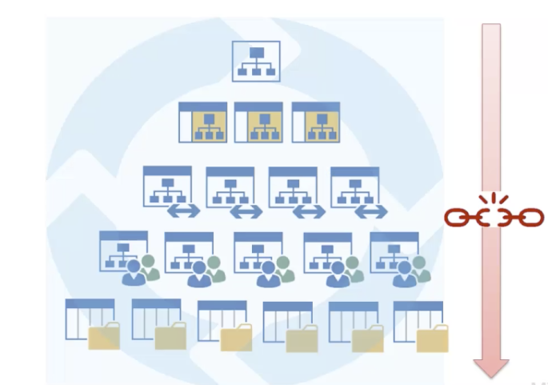

You can read more about Permission Inheritance at <https://docs.microsoft.com/en-us/sharepoint/what-is-permissions-inheritance>

🡪 Log in to the offering SharePoint site as you did in the last lab

[ICT292 Information Systems Management 2023 TJA - Home (sharepoint.com)](https://murdochuniversity.sharepoint.com/sites/ICT292_2023TJA)

🡪 You will now create a subsite that will have your student number as the site title (if you can’t remember how to do this, see the instructions in Lab 01).

🡪 Once you have done that, create a subsite **under your subsite** and call it “your student number” followed by subsite:

In creating this subsite, you had the option of being able to inherit permissions from the parent site:

**Q. Can any of your classmates see your subsite? Can you see any of your classmates’ subsites? Why or why not?**

This concept of permission inheritance is very important in design of a larger SharePoint site. When creating sub-sites, lists, libraries etc, it is important to understand what permissions are attached to the resource. It is also important to plan so that sensitive and non-sensitive data can be separated to make management easier.

### Permission Levels

There are, by default, five permission levels in SharePoint.

|  |  |
| --- | --- |
| Permission Level | Description |
| Full Control | This permission level contains all permissions. It is assigned to the site Owners group. This level cannot be customized. |
| Design | Can create lists and document libraries, edit pages and apply themes, borders and style sheets in the site. |
| Contribute | Can add, edit and delete items in existing lists and document libraries. Assigned to the Members group of each site by default. |
| Read | Read only access to the site. Users and groups with this permission level can view items and pages, open items and documents. Assigned to the visitors group by default. |
| Limited Access | This level is designed to be combined with fine-grained permissions to give users access to a specific list, document library, item or document without giving them access to the entire site. |

Adapted from: <https://www.uvic.ca/systems/assets/docs/pdfs/web/sharepoint/Permissions_and_security.pdf> Accessed 5th August 2016

**Q. What permission level do you think you might have for the following sites:**

* [Information Systems Management (ICT292) (sharepoint.com)](https://murdochuniversity.sharepoint.com/sites/ICT292)
* [Information Systems Management 2022 S2 - Home (sharepoint.com)](https://murdochuniversity.sharepoint.com/sites/ICT292_2022S2)
* [Information Systems Management 2022 TMA - Home (sharepoint.com)](https://murdochuniversity.sharepoint.com/sites/ICT292_2022TMA)
* The sub-site you created yourself.

🡪 In your own sub-site, go to Site Settings and select Site Permissions under Users and Permissions. You should see a screen that looks something like this:

🡪 Without selecting your name, click the Check Permissions box, and type Fatuma Namisango into the User/Group box:

🡪 Click “Check Now” and see what I can do to your site.

You will now add another student from your class to your site and grant them Read access to your sub site by creating a Group and adding them to it.

🡪 From your site, go to Site Settings and select Site Permissions from the Users and Permissions Group

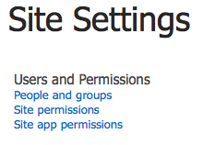

Select Create Group

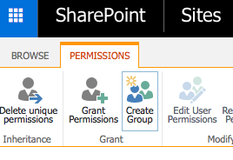

🡪 Name the group something like ReadMySite and select Read from the Permissions level group at the bottom of the page. Then click Create.

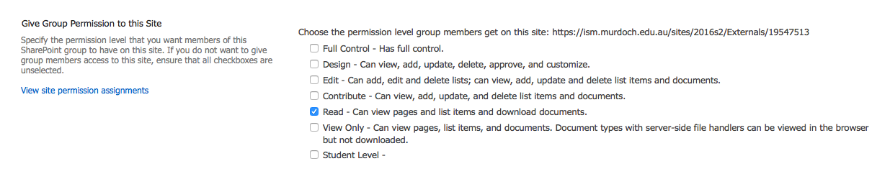

🡪 Select **New** then **Add users to this group**, and type in the name of your partner for the lab. If you don’t want to send them an email invitation, uncheck the Send an email invitation box. **\*\*\*I would prefer that you didn’t add me \*\*\***

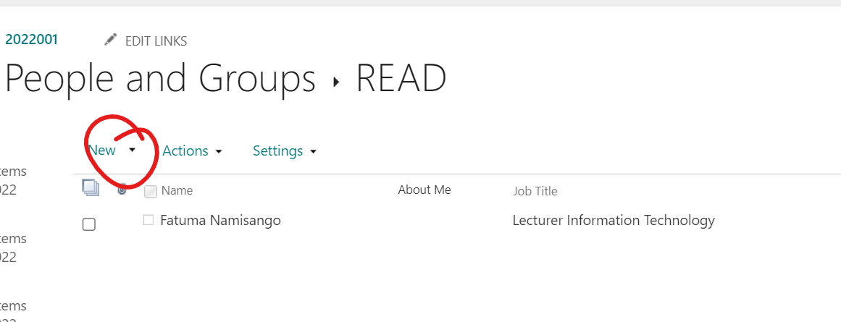

🡪 Once you have added each other, go to your partner’s site and see what you can and cannot do.

If you have time, experiment with other permission levels.

## In the next lab:

We will be looking at lists and libraries. Make sure that you understand what we have covered in this lab so you will be able to make best use of next week’s lab.

## Document History:

Version 1.0: 6th August 2016

Version 2.0: 15th November 2016

Version 2.1: 12th January 2017

Version 3.0: 23rd August 2017

Version 3.1: 7th May 2018

Version 4.0 (SPO): 12th January 2019

Version 4.1: 4th August 2019

Version 4.2: 28th April 2020

Version 4.3: 16th July 2020

Version 4.4: 9th July 2022